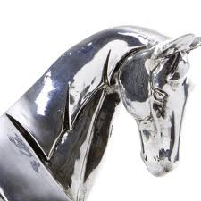
STRATHENDRICK GOLF CLUB
‘Silver Horse’ Mixed Open
(Stableford Greensomes)
Sat 14th Sept 2024

Entry Form - Closing Date for entries Wed 11th Sept 2024 - so Gee Up!!
Entry Fee: £20 per couple (includes ‘½ time’ tea/home baking)
  - The competition is open to members of a recognised golf club with a competition handicap
  - Each team should consist of a Lady and Gent. Max handicap allowance given:
Ladies (36), Gents (28)
  - The competition will be played over 18 holes in a Stableford, Greensomes format
  - R&A AND Local rules apply
Preferred Start: | 08:30-10:00 |  | 12:30-14:00 |  | NB. There are NO tee times between 10-12.30
Allocated start times will be verified via text and by email to the Lead contact.
Following detail for ALL players must be provided:
PLAYER | HOME CLUB | HCAP
Lady:
Gent:
Lead Contact (Player A) Full Contact Details:
Address
Email
PAYMENT (to be made before the event) Select method ‘X’
Preferred method: Payment, where possible, to be made direct into SGC Bank:
Account number: 00258592 Account Name: Strathendrick Golf Club
Sort Code: 83-17-39 Ref: ‘Mixed/Surname’
OR by Cheque made payable to: Strathendrick Golf Club (add ref. as above on back)
Return entry form to Marie Fitzpatrick, 55 Oxhill Place, Dumbarton G82 4EX
or via email: mariefitzpatrick@blueyonder.co.uk
Enquiry - Mob: 07983 266287
NB. The personal details on this form are required as a condition of your entry to this competition. Your details may be stored electronically for the duration of the competition plus one year. Names of winners will be posted internally and on the Club website. No personal details will be shared with other third parties..

