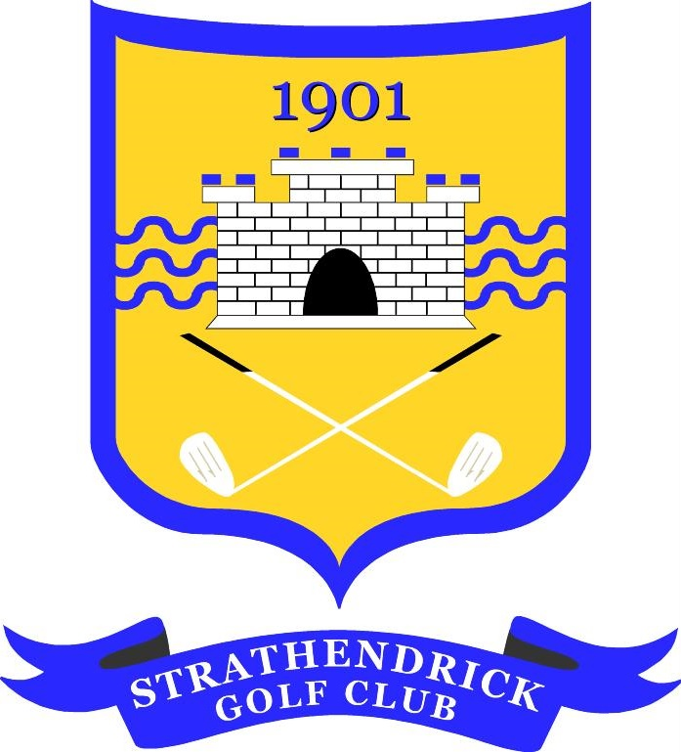
STRATHENDRICK GOLF CLUB

GLENGOYNE GREENSOMES TEAM OPEN COMPETITION
Sunday 12th May 2024
Entry Form - Closing Date Wednesday 8th May
Entry Fee - £60 per Team
(Includes NTP)

1. Teams will consist of 4 players in 2 pairs; playing in Greensomes format any combination of Gents/Ladies or Juniors
2. All players must be members of a recognised Golf Club and have a current handicap.
3. Max Handicap allowance given: Gents (28), Ladies (36)
4. Scoring will be on a Stableford basis
Preferred Start (x) | Morning |  | Afternoon
Allocated start times will be verified via text and by email to the Lead contact.
Following detail for ALL players must be provided:
PLAYERS |  | HOME CLUB | HCAP | Mob/Tel No.
A
B
C
D
Lead Contact (Player A) Full Contact Details:
Address
Email
PAYMENT – payment to be made before the event (x)
Preferred method: Payment, where possible, to be made direct into SGC Bank:
Account number: 00258592 Account Name: Strathendrick Golf Club
Sort Code: 83-17-39 Ref: ‘Glengoyne’ ‘Surname’ (of lead player)
OR by Cheque made payable to: Strathendrick Golf Club (ref as above on back)
Return entry form to: Davetheshintyman@btinternet.com
Or by post: David MacVicar 18 Upper Glenfinlas St, Helensburgh G84 7HD Tel. 01436 677 959
Other Enquiries: info@strathendrickgolfclub.co.uk
The personal details on this form are required as a condition of your entry to this competition. Your details may be stored electronically for the duration of the competition plus one year and may also be shared with DotGolf and the Scottish Golf Union but no other third party.

