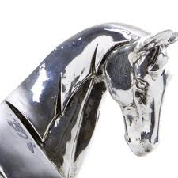
STRATHENDRICK GOLF CLUB, DRYMEN
‘Silver Horse’
Mixed Open
(Stableford Greensomes)
Sat 14th Sept 2019

  - Entry Fee: £15 per couple (‘½ time’ tea/home baking included)
Entry Form - Closing Date for entries Mon 9th Sept 2019 - so Gee Up!!
Name:
Address:
Tel (Mobile):
Tel (Home):
Email:

PLAYER | CLUB | HCAP
Lady:
Gent:

Preferred Start (am or pm): . . . . . . Allocated Start Time . . . . . .
NB. as Strathendrick is a nine-hole course there are NO tee-times between 10.00 and 12.30 to allow for turnaround. Available times are between 8.30-10am and 12.30-2pm.
- The competition is open to members of a recognised golf club with a competition handicap
- Each team should consist of a Lady and Gent. Max handicap allowance given:
Ladies (36), Gents (28)
- The competition will be played over 18 holes in a Stableford, Greensomes format
  - Return with fee (cheques payable to Strathendrick Golf Club) to:
  - Marie Fitzpatrick, 55 Oxhill Place, Dumbarton G82 4EX
  - Mob: 07983 266 287
  - email: mariefitzpatrick@blueyonder.co.uk

NB. The personal details on this form are required as a condition of your entry to this competition. Your details may be stored electronically for the duration of the competition plus one year and may also be shared with Club Systems International, How Did I Do and the Scottish Golf Union but no other third party.

