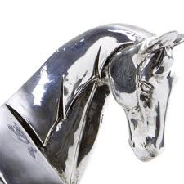
STRATHENDRICK GOLF CLUB, DRYMEN
‘Silver Horse’ Mixed Open
(Stableford Greensomes)
Sat 11 ^{th} Sept 2021

Entry Fee: £20 per couple (includes ‘½ time’ tea/home baking)
Entry Form - Closing Date for entries Wed 8th Sept 2021- so Gee Up!!
Name:
Address:
Tel (Mobile):
Tel (Home):
Email:

PLAYER | HOME CLUB | HCAP
Lady:
Gent:

Preferred Start: | 08:30-10:00 |  | 12:30-14:00 |  | Nb. Allocated Tee Time will be notified by text or email
RULES
- The competition is open to members of a recognised golf club with a competition handicap
- Each team should consist of a Lady and Gent. Max handicap allowance given:
Ladies (36), Gents (28)
- The competition will be played over 18 holes in a Stableford, Greensomes format
- R&A AND Local rules apply
PAYMENT
- Preferred method: Payment can be made direct into SGC Bank (ref: ‘Mixed’ and your Surname):
Account number: 00258592 (a/c Name: Strathendrick Golf Club)
Sort Code: 83-17-39
- OR by Cheque: Made payable to: Strathendrick Golf Club
Return entry form to Marie Fitzpatrick, 55 Oxhill Place, Dumbarton G82 4EX or via email: mariefitzpatrick@blueyonder.co.uk
Enquiry: Mob: 07983 266 287
NB. The personal details on this form are required as a condition of your entry to this competition. Your details may be stored electronically for the duration of the competition plus one year and may also be shared with Club Systems International, How Did I Do and the Scottish Golf Union but no other third party.

