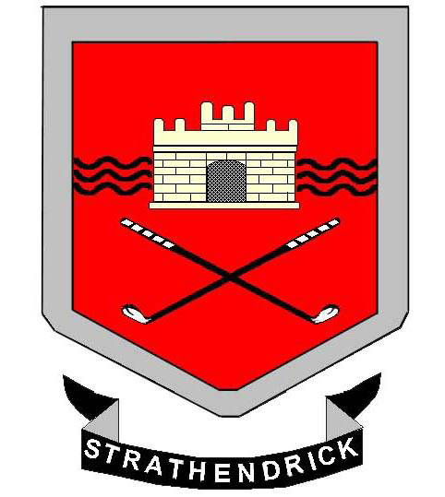 Strathendrick Golf Club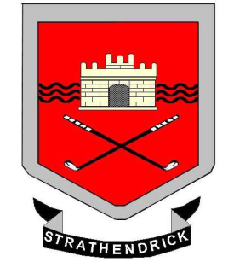

OPEN GREENSOME TEAM COMPETITION
FOR THE BOWMORE TROPHY

Sunday 27th May 2018
Entry Form

Team Name:
Player A | Hcp | Player B | Hcp
CDH - |  | CDH -
Player C | Hcp | Player D | Hcp
CDH - |  | CDH -
Preferred Start Time - AM / PM

Player A Home Club…………………………….. E-mail…………………………………….

ENTRY FEE: £30 per Team. CLOSING DATE for Entries: Sat 25th May
1. Teams will consist of 4 players in 2 pairs; playing in Greensome format;
2. All players must be members of a recognised Golf Club and have a current handicap.
3. A handicap certificate will be required on the day.
4. Scoring will be on a Stableford basis.

Return to: The Match Secretary, Strathendrick Golf Club, Glasgow Road, Drymen G63 0EY

ALL CHEQUES SHOULD BE MADE PAYABLE TO:-STRATHENDRICK GOLF CLUB

Starting times can be verified by emailing – info@strathendrickgolfclub.co.uk

